**Department of IT and Computer Science**

**Pak-Austria Fachhochschule: Institute of Applied Sciences and Technology, Haripur, Pakistan**

**A Report on**

The Network Emulator

**Submitted to**

Engr. Rafi Ullah

Data Structures and Algorithms Lab

**Submitted By**

Muhammad Suleman

Yaseen Ejaz Ahmed

Department of IT and Computer Science

**Table of Contents**

**Overview** 3

**Introduction** 4

**Scope** 4

**Components** 4

**Methodology** 5

Sorting 6

Priority Queue 6

Tree 6

Traversal 6

**Conclusion** 7

**List of Figures:**

Figure 1: Network 3

# **Overview**

A network is a collection of interconnected electronic equipment such as routers, computers, and other similar devices, each with its own unique identifying address (e.g., IP address). The destination (recipient) address is used to send a message from one device to another. To arrive to the intended target device, the message must clearly follow a route (i.e., a path of routers) through the network. Each router along the path examines the message's destination address before forwarding it to the next router or the target computer. A router often keeps a table (called a routing table) for this purpose, which contains information about where a message with a certain destination address should be sent.

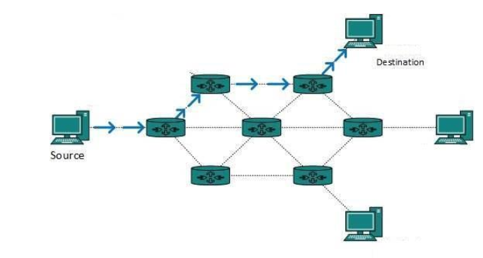

## **Figure 1: Network**

# **Introduction**

A network is two or more computers (or other electronic devices) that are connected together, usually by cables or Wi-Fi. A server is a powerful computer that often acts as a central hub for services in a network, e.g. emails, internet access and file storage. We can also use a modem in a home network other than a server. Each computer connected to a server is called a client.

In the broadest sense, a network is any interconnected group of people or things capable of sharing meaningful information with one another. In a technology context, network is usually short for "computer network" or "data network" and implies that computers are the things sharing the meaningful information.

# **Scope**

The scope of this project is to create a network, send and receive messages at a faster time with accurate results. By accurate results we mean no data shall be lost. This can be a better experience for people in a network. They can get faster and the same data sent by the user.

# **Components**

The following components shall be used for the network:

* Modem (Root or Starting)
* Router (Nodes)
* Computers (Leaves)

# **Methodology**

The methodology in implementing a network is to use trees. These trees are used to connect all the computers to the routers and the routers to the modem.

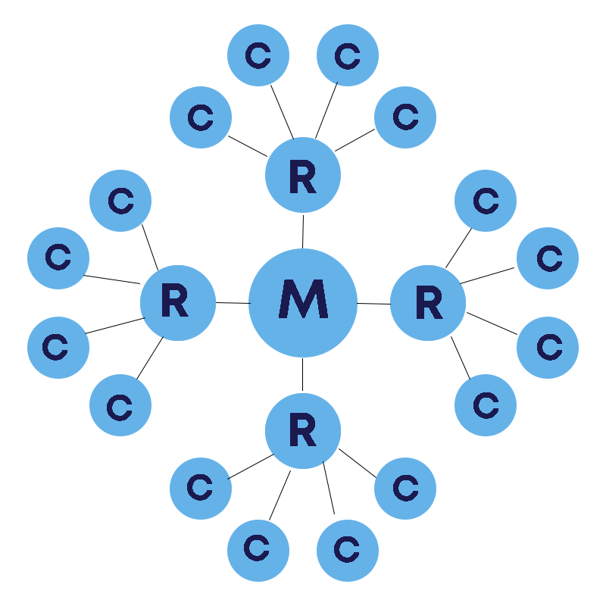

**Working:**

* Modem is the head.
* Four routers are connected to the modem.
* Each router has four computers. (16 total computers)

We shall take the priorities, the messages and the IP addresses from the user. User shall enter the values will be stored in an array. There shall be three separate arrays.

## **Sorting:**

Arrays shall be sorted with respect to the priority array. Insertion sort will be used to sort the priority array and the IP address and message array.

## **Priority Queue:**

We can prioritize different messages with the priority numbers. As we have sorted the arrays in descending order or highest to lowest priority, our priority queue shall be constructed. We can dequeue from the head of the queue.

## **Tree:**

We constructed our tree using different classes of IP addresses. A, B, C, D classes are used in this case for each router. Comparisons shall be done in traversal.

## **Traversal:**

We can traverse through the network using conditions. IP addresses have different ranges for different classes. We can use this logic and compare all node’s data for faster and accurate traversal in the network.

# **Conclusion**

In conclusion, the network built is to connect all computers with routers and a modem. The modem is used to convert the IP addresses into different classes for easier communication through the router. Routers contain direct IP class with other computers. Queues are used as first message will be sent first. Using all these concepts in mind, we can create a network using Data Structures and other different concepts.

**Program Code:**

**User Input:**

#include <iostream>

#include <conio.h>

using namespace std;

class node

{

public:

node* head=NULL; //head

node* next;

string mssg;

void Enqueue(string msg)

{

node* temp=new node;

temp->mssg=msg;

temp->next=NULL;

if(head==NULL)

{

head=temp;

}

else

{

node* ptr=head;

while(ptr->next!=NULL)

{

ptr=ptr->next;

}

ptr->next=temp;

}

}

string dequeue()

{

string MSG;

node *temp=head;

MSG=head->mssg;

if(head->next==NULL)

return MSG;

else

{

head=head->next;

}

}

bool isEmpty()

{

if(head==NULL)

return true;

return false;

}

void show()

{

node *ptr=head;

cout << endl;

while(ptr->next!=NULL)

{

cout << ptr->mssg << "\n";

ptr=ptr->next;

}

cout << ptr->mssg << "\n";

}

}N;

class Network

{

public:

string data;

// Pointers

Network *modem;

Network *up;

Network *down;

Network *left;

Network *right;

Network()

{

modem=up=down=left=right= NULL;

data="\0";

}

void Creat_Network()

{

string arr[4] = {"up","left","right","down"};

for (int i = 0; i < 5; ++i)

{

Network *temp = new Network;

if (modem==NULL)

modem=temp;

else

{

if (arr[i-1]=="up")

{

modem->up = temp;

temp->data = "A";

for (int j = 0; j < 4; ++j)

{

Network *temp1 = new Network;

if (arr[j] == "down")

{

temp->down = temp1;

temp1->data = "1.1.1.1";

}

else if (arr[j] == "up")

{

temp->up = temp1;

temp1->data = "2.2.2.2";

}

else if (arr[j] == "left")

{

temp->left= temp1;

temp1->data = "3.3.3.3";

}

else if (arr[j] == "right")

{

temp->right = temp1;

temp1->data = "4.4.4.4";

}

}

}

if (arr[i-1]=="down")

{

modem->down = temp;

temp->data = "D";

for (int j = 0; j < 4; ++j)

{

Network *temp1 = new Network;

if (arr[j] == "up")

{

temp->up = temp1;

temp1->data = "225.100.0.1";

}

if (arr[j] == "left")

{

temp->left = temp1;

temp1->data = "230.0.0.1";

}

if (arr[j] == "right")

{

temp->right = temp1;

temp1->data = "235.35.35.35";

}

if (arr[j] == "down")

{

temp->down = temp1;

temp1->data = "233.33.0.3";

}

}

}

if (arr[i-1]=="left")

{

modem->left = temp;

temp->data = "B";

for (int j = 0; j < 4; ++j)

{

Network *temp1 = new Network;

if (arr[j] == "up")

{

temp->up = temp1;

temp1->data = "154.68.1.1";

}

if (arr[j] == "left")

{

temp->left = temp1;

temp1->data = "169.0.0.1";

}

if (arr[j] == "right")

{

temp->right = temp1;

temp1->data = "129.1.1.1";

}

if (arr[j] == "down")

{

temp->down = temp1;

temp1->data = "191.68.1.1";

}

}

}

if (arr[i-1]=="right")

{

modem->right = temp;

temp->data = "C";

for (int j = 0; j < 4; ++j)

{

Network *temp1 = new Network;

if (arr[j] == "up")

{

temp->up = temp1;

temp1->data = "192.168.1.1";

}

if (arr[j] == "left")

{

temp->left = temp1;

temp1->data = "195.168.0.10";

}

if (arr[j] == "right")

{

temp->right = temp1;

temp1->data = "200.1.1.1";

}

if (arr[j] == "down")

{

temp->down = temp1;

temp1->data = "220.20.20.20";

}

}

}

}//Else End

}//For loop End

}// End of Creat_Network

void traverse(string IP[], int size)

{

Network *ptr = modem;

for (int i = 0; i <size; ++i)

{

string str,dummy;

str=dummy="\0";

dummy = IP[i];

int x=0;

while(dummy[x]!='.')

{

str = str + dummy[x];

++x;

}

// Ranges

if (str>="1" && str <="126")

{

ptr = modem->up;

}

else if (str>="127" && str <="191")

{

ptr = modem->left;

}

else if (str>="192" && str <="223")

{

ptr = modem->right;

}

else if (str>="224" && str <="239")

{

ptr = modem->down;

}

bool flag= false;

if (ptr->up->data == IP[i] || ptr->down->data == IP[i] || ptr->right->data == IP[i] || ptr->left->data == IP[i])

{

flag = true;

cout << "\nComputer Has Been Found SuccessFully!";

cout << "\nThe Message = \' " << N.dequeue() << " \' Has Been Delivered!" << endl;

}

else if (flag == false)

{

cout << "\n Computer Not Found!" << endl;

N.dequeue();

}

}

}

};

void InsertionSort (string Msg[], int Prt[], string IP[],int n)

{

int prt,j;

string msg;

string ip;

//insertion sort

for(int i=1;i<n;i++)

{

msg = Msg[i];

prt = Prt[i];

ip = IP[i];

j = i-1;

while(j>=0 && Prt[j]<prt)

{

Msg[j+1] = Msg[j];

Prt[j+1] = Prt[j];

IP[j+1] = IP[j];

j--;

}

Msg[j+1] = msg;

Prt[j+1] = prt;

IP[j+1] = ip;

}

cout << "\n\nSorted Based on Priority";

for(int i=0;i<n;i++)

{

cout << "\n" << i+1 << ". " << Prt[i] << "\t" << Msg[i] << "\t" << IP[i];

N.Enqueue(Msg[i]);

}

cout << "\n" << endl;

}

int main()

{

cout<<"\n\n\t\t\tTHE NETWORK EMULATOR\nInput From User\n";

Network n;

n.Creat_Network();

string s[10];

int p[10];

string ip[10];

int opt;

for(int i=0;i<10;i++)

{

s[i] = "\0";

p[i] = 0;

}

int i=0;

int j=0;

do

{

cout << "\n\nEnter a priority (-1 to exit) : ";

cin >> p[i];

if(p[i]!=-1)

{

cout << "Enter a message : ";

cin >> s[i];

cout << "Enter the IP : ";

cin >> ip[i];

i++;

j++;

}

else break;

}

while(p[i]!=-1);

cout << "\n\n-> Number of messages = " << j;

string message[j];

int priority[j];

string IP[j];

for(int k=0;k<j;k++)

{

message[k]=s[k];

priority[k]=p[k];

IP[k]=ip[k];

cout << "\n" <<k+1 << ". " << priority[k] << "\t" << message[k] << "\t" << IP[k];

}

InsertionSort(message,priority,IP,j);

cout << "\n The Queue = ";

N.show();

cout << "\n Looking For Computer...";

cout << "\n";

n.traverse(IP, j);

}

**File Handling:**

#include <iostream>

#include <conio.h>

#include <fstream>

using namespace std;

class node

{

public:

node* head=NULL; //head

node* next;

string mssg;

void Enqueue(string msg)

{

node* temp=new node;

temp->mssg=msg;

temp->next=NULL;

if(head==NULL)

{

head=temp;

}

else

{

node* ptr=head;

while(ptr->next!=NULL)

{

ptr=ptr->next;

}

ptr->next=temp;

}

}

string dequeue()

{

string MSG;

node *temp=head;

MSG=head->mssg;

if(head->next==NULL)

return MSG;

else

{

head=head->next;

}

}

bool isEmpty()

{

if(head==NULL)

return true;

return false;

}

void show()

{

node *ptr=head;

cout << endl;

while(ptr->next!=NULL)

{

cout << ptr->mssg << " -> ";

ptr=ptr->next;

}

cout << ptr->mssg << "\n";

}

}N;

class Network

{

public:

string data;

// Pointers

Network *modem;

Network *up;

Network *down;

Network *left;

Network *right;

Network()

{

modem=up=down=left=right= NULL;

data="\0";

}

void Creat_Network()

{

string arr[4] = {"up","left","right","down"};

for (int i = 0; i < 5; ++i)

{

Network *temp = new Network;

if (modem==NULL)

modem=temp;

else

{

if (arr[i-1]=="up")

{

modem->up = temp;

temp->data = "A";

for (int j = 0; j < 4; ++j)

{

Network *temp1 = new Network;

if (arr[j] == "down")

{

temp->down = temp1;

temp1->data = "1.1.1.1";

}

else if (arr[j] == "up")

{

temp->up = temp1;

temp1->data = "2.2.2.2";

}

else if (arr[j] == "left")

{

temp->left= temp1;

temp1->data = "3.3.3.3";

}

else if (arr[j] == "right")

{

temp->right = temp1;

temp1->data = "4.4.4.4";

}

}

}

if (arr[i-1]=="down")

{

modem->down = temp;

temp->data = "D";

for (int j = 0; j < 4; ++j)

{

Network *temp1 = new Network;

if (arr[j] == "up")

{

temp->up = temp1;

temp1->data = "225.100.0.1";

}

if (arr[j] == "left")

{

temp->left = temp1;

temp1->data = "230.0.0.1";

}

if (arr[j] == "right")

{

temp->right = temp1;

temp1->data = "235.35.35.35";

}

if (arr[j] == "down")

{

temp->down = temp1;

temp1->data = "233.33.0.3";

}

}

}

if (arr[i-1]=="left")

{

modem->left = temp;

temp->data = "B";

for (int j = 0; j < 4; ++j)

{

Network *temp1 = new Network;

if (arr[j] == "up")

{

temp->up = temp1;

temp1->data = "154.68.1.1";

}

if (arr[j] == "left")

{

temp->left = temp1;

temp1->data = "169.0.0.1";

}

if (arr[j] == "right")

{

temp->right = temp1;

temp1->data = "129.1.1.1";

}

if (arr[j] == "down")

{

temp->down = temp1;

temp1->data = "191.68.1.1";

}

}

}

if (arr[i-1]=="right")

{

modem->right = temp;

temp->data = "C";

for (int j = 0; j < 4; ++j)

{

Network *temp1 = new Network;

if (arr[j] == "up")

{

temp->up = temp1;

temp1->data = "192.168.1.1";

}

if (arr[j] == "left")

{

temp->left = temp1;

temp1->data = "195.168.0.10";

}

if (arr[j] == "right")

{

temp->right = temp1;

temp1->data = "200.1.1.1";

}

if (arr[j] == "down")

{

temp->down = temp1;

temp1->data = "220.20.20.20";

}

}

}

}//Else End

}//For loop End

}// End of Creat_Network

void traverse(string IP[], int size)

{

Network *ptr = modem;

for (int i = 0; i <size; ++i)

{

string str,dummy;

str=dummy="\0";

dummy = IP[i];

int x=0;

while(dummy[x]!='.')

{

str = str + dummy[x];

++x;

}

// Ranges

if (str>="1" && str <="126")

{

ptr = modem->up;

}

else if (str>="127" && str <="191")

{

ptr = modem->left;

}

else if (str>="192" && str <="223")

{

ptr = modem->right;

}

else if (str>="224" && str <="239")

{

ptr = modem->down;

}

bool flag= false;

if (ptr->up->data == IP[i] || ptr->down->data == IP[i] || ptr->right->data == IP[i] || ptr->left->data == IP[i])

{

flag = true;

cout << "\nComputer Has Been Found SuccessFully!";

cout << "\nThe Message = \' " << N.dequeue() << " \' Has Been Delivered!" << endl;

}

else if (flag == false)

{

cout << "\n Computer Not Found!" << endl;

N.dequeue();

}

}

}

};

void InsertionSort (string Msg[], int Prt[], string IP[],int n)

{

int prt,j;

string msg;

string ip;

//insertion sort

for(int i=1;i<n;i++)

{

msg = Msg[i];

prt = Prt[i];

ip = IP[i];

j = i-1;

while(j>=0 && Prt[j]<prt)

{

Msg[j+1] = Msg[j];

Prt[j+1] = Prt[j];

IP[j+1] = IP[j];

j--;

}

Msg[j+1] = msg;

Prt[j+1] = prt;

IP[j+1] = ip;

}

cout << "\n\nSorted Based on Priority";

for(int i=0;i<n;i++)

{

cout << "\n" << i+1 << ". " << Prt[i] << "\t" << Msg[i] << "\t" << IP[i];

N.Enqueue(Msg[i]);

}

cout << "\n" << endl;

}

int main()

{

cout<<"\n\n\t\t\tTHE NETWORK EMULATOR\nReading From a File\n";

Network n;

n.Creat_Network();

string s[10];

int p[10];

string ip[10];

int opt;

for(int i=0;i<10;i++)

{

s[i] = "\0";

p[i] = 0;

ip[i]="\0";

}

int i=0;

int j=-1;

ifstream file("Net.txt");

while(!file.eof())

{

string a;

char b;

string xx;

string c;

getline(file,a); //mssg

int pr;

file>>b;

pr=int(b)-48; //priority

getline(file,xx);

getline(file,c); //IP

s[i]=a;

p[i]=pr;

ip[i]=c;

i++;

j++;

}

cout << "\n\n-> Number of messages = " << j;

string message[j];

int priority[j];

string IP[j];

for(int k=0;k<j;k++)

{

message[k]=s[k];

priority[k]=p[k];

IP[k]=ip[k];

cout << "\n" <<k+1 << ". " << priority[k] << "\t" << message[k] << "\t" << IP[k];

}

InsertionSort(message,priority,IP,j);

cout << "\n The Queue = ";

N.show();

cout << "\n Looking For Computer...";

cout << "\n";

n.traverse(IP, j);

}